Brainstorming, Idea Generation and Prioritization
Ideation Phase | Options and selected approach
Project | Automated Network Request Management | Date | 20 October 2026
Owner / demonstrator | PILLEM RAHUL | SkillWallet ID | SWUID2026232277
Platform | ServiceNow PDI | Repository | https://github.com/rahulp06/Automated_Network_Request_Management_in_ServiceNow

Phase: 1. Ideation Phase

Options considered
Idea | Priority | Disposition | Reason
Service Catalog form with required-variable validation | High | Selected / implemented | Gives a consistent user entry point and prevents incomplete orders.
Standard REQ and RITM records | High | Selected / implemented | Uses native ServiceNow tracking and relationships.
Existing approval/rejection flow | High | Selected / implemented | Provides decision handling without replacing the working configured flow.
Lifecycle email notifications | High | Selected / implemented | Notifies stakeholders; SMTP delivery was tested with a QA recipient route.
Fulfillment automation into network systems | Medium | Future scope | Would require integration and operational safeguards not evidenced in this PDI build.
Dashboards / SLA analytics | Medium | Future scope | Could improve reporting after meaningful operational data is available.
Production email routing and inbound processing | Low for demo | Deferred | Requires organizational mail/security approvals and is not needed for outbound-demo proof.

Prioritization rationale
The chosen approach prioritizes demonstrable end-to-end workflow behavior using native ServiceNow catalog and request records. It avoids adding unverified external integrations and keeps mail delivery in a non-production test route. Future items are proposals, not claimed implemented features.

Selected concept
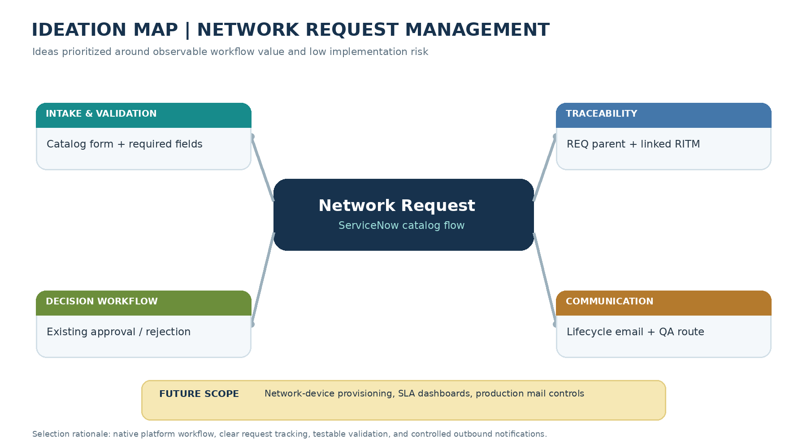
Figure 1. Ideation map showing the selected capability areas and deferred future scope.
Selected solution Network Request catalog → mandatory validation → REQ/RITM creation → existing approval/rejection path → lifecycle notifications → request/fulfillment tracking.

